MECHATRONIC SYSTEM INTEGRATION

MCTA 3203

WEEK 7:

PLC INTERFACING WITH MICROCONTROLLER AND PC OVER ETHERNET/IP (VER 2.0)

SECTION 1

SEMESTER 2, 2025/2026

INSTRUCTOR:

ASSOC. PROF. EUR. ING. IR. TS. GS. INV. DR. ZULKIFLI BIN ZAINAL DR. WAHJU SEDIONO

DATE OF SUBMISSION: 18 MAY 2026

GROUP 6
NAME | NO. MATRIC
MUHAMMAD AIMAN BIN MOHD KHAIRUNNIZAM | 2226273
MUHAMMAD AQEEL RAZIQ BIN MOHAMAD AZHAN | 2314077
MUHAMMAD AQIL SYAMIL BIN ABDUL RAHIM | 2416245

Table of Contents
Abstract 3
Introduction 3
Materials and Equipment 4
Experimental setup 4
Methodology 5
Data Collection 7
Data Analysis 8
Results 8
Discussion 9
Conclusion 9
Recommendations 10
References 10
Appendices 11
Acknowledgments 12
Student’s Declaration 13

Abstract
This laboratory report details the software configuration, physical circuit interfacing, and compilation steps required to deploy industrial Programmable Logic Controller (PLC) programs onto a commercial microcontroller unit. Using the open-source, IEC 61131-3 compliant OpenPLC Editor workspace, a standard industrial programming infrastructure was successfully combined with common embedded systems hardware. The project progressed from compiling an automated blinking indicator rhythm using Ton (Timer On-Delay) and Tof (Timer Off-Delay) internal functional macros to deploying a human-in-the-loop self-latching start-stop equipment control loop. Performance evaluations verified that standard industrial addressing models effectively govern physical hardware operations, matching standard manufacturing control profiles.

Introduction
In manufacturing technology and modern plant engineering, the Programmable Logic Controller (PLC) stands as the primary structural computer architecture used to handle electromechanical equipment and factory automation loops. Unlike microcontrollers that compile bare-metal procedural instructions, industrial PLCs are designed for deterministic performance, high electrical reliability, and intuitive standardized graphical representation layers—primarily Ladder Diagram (LD) networks.
As industrial facilities move toward connected manufacturing paradigms, modern mechatronic engineers must understand how to link standard embedded electronics with traditional factory networks over Ethernet/IP pipelines. This laboratory module explores these engineering principles by using the OpenPLC Editor ecosystem. By compiling software within this cross-platform suite and assigning IEC 61131-3 standardized physical pointer paths, a standard microcontroller board is systematically transformed to execute deterministic industrial control rungs.

Materials and Equipment
- OpenPLC Editor software
- Arduino Board
- 2 Push Button Switches
- LED
- Resistors
- Jumper Wires
- Breadboard

Experimental setup
- Input-Output Variable Mappings
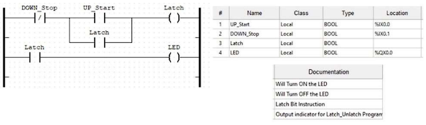
- UP_Start (PB1): Assigned location variable %IX0.0 (Wired directly to Arduino digital input Pin 2).
- DOWN_Stop (PB2): Assigned location variable %IX0.1 (Wired directly to Arduino digital input Pin 3).
- LED Output (LED1): Assigned location variable %QX0.0 (Wired directly to Arduino digital output Pin 7).
- Hardware Connection Circuit Schematics
The electronic layout for the Start-Stop control system was built according to the schematic below:
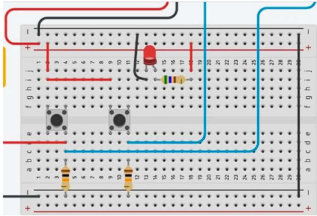

Methodology

Project Creation and Environment Initialization
- The OpenPLC Editor software application environment was launched.
- A clean project directory folder was generated via the path menu File > New, and named systematically to initialize the underlying repository files.
- Inside the Create a New POU configuration prompt window, the project structural name was declared, and the base language configuration was toggled to LD (Ladder Diagram).
- Developing the Self-Latching Start-Stop System
- A new project workspace was structured to deploy the secondary task requirements.
- The input-output interface list was structured by declaring four operational variables with specific location indices:
- UP_Start $\rightarrow$ Mapped to Local BOOL variable at location %IX0.0.
- DOWN_Stop $\rightarrow$ Mapped to Local BOOL variable at location %IX0.1.
- Latch $\rightarrow$ Mapped to an internal Local storage BOOL flag.
- LED $\rightarrow$ Mapped to Local output BOOL variable at location %QX0.0.
- Rung 1 was developed by wiring an inverted/normally-closed (NC) contact tied to DOWN_Stop in series with a parallel branch. This parallel sub-network paired a normally-open (NO) contact driven by UP_Start alongside a latching feedback contact tied to internal variable Latch. The serial chain terminated on an output coil tied to Latch.
- Rung 2 was formed by placing a normally-open contact driven by variable Latch and connecting it directly to an output coil linked to variable LED.
- Code functionality checks were verified using the simulation tool to evaluate variable logic changes under simulated button presses.
- Hardware Target Deployment
- The host computer was connected to the target microcontroller platform via a USB serial interface cable. The designated computer communications serial address (COM port number) was identified and recorded through system management panels.
- In the variable allocation dashboard, the specific target physical syntax coordinates were written into the variable allocation cells.
- The program upload icon was selected from the main toolbar to bring up the Transfer Program to PLC interface panel.
- Dropdown selections were modified to specify the exact target board type configuration (e.g., matching the respective board variant definitions) and the recorded COM port string identifier.
- The Transfer to PLC command button was triggered, launching automated cross-compilation toolchains that compiled the ladder configuration into a binary executable and uploaded it directly into the microcontroller flash storage memory.

Data Collection
The internal operational states, variable address mappings, and compilation parameters recorded during the implementation phases are summarized below:
- Compiler Infrastructure Metrics:
- Target Language Structure: IEC 61131-3 Compliant Ladder Diagram (LD).
- Communication Pipeline Protocols: Modbus TCP / Ethernet/IP encapsulations over USB serial bridges.
- Variable Allocation Registers:
Variable Reference Name | Structural Allocation Class | IEC 61131-3 Location Token | Target Board Pin Destination | Logic Action Matrix Behavior
UP_Start | Local | %IX0.0 | Digital Pin 2 | Registers logic HIGH upon physical tactile closure.
DOWN_Stop | Local | %IX0.1 | Digital Pin 3 | Registers logic HIGH upon physical tactile closure.
Latch | Local | None | None | Internal bit instruction; latches the output state.
LED | Local | %QX0.0 | Digital Pin 7 | Drives the physical indicator LED high or low.

Data Analysis
Analyzing the system data highlights key structural characteristics of deploying industrial software structures onto microcontrollers:
- Self-Latching Circuit Mechanics: The design of the Start-Stop control sequence relies on an internal boolean memory bit (Latch) to maintain state. Because the physical tactile pushbuttons are momentary, they output a logic HIGH only during physical compression. To keep the system running after the start button is released, a parallel latch contact is wired across the UP_Start input. Once UP_Start pulses high, the output coil turns on, closing the parallel Latch contact. This establishes an alternate electrical path that maintains logic flow even after the UP_Start contact breaks open.
- Electrical Input Dynamics: The use of 10 kΩ resistors connected to ground creates a reliable pulldown circuit configuration. High-impedance digital pins on CMOS microcontrollers are highly sensitive to environmental electromagnetic fields. Without a clear ground path, floating pins can register random transitions between states. The pulldown resistors tie the inputs cleanly to 0V (LOW) when the switches are open, returning a reliable logic HIGH (5V) only during positive contact closure.

Results
The experimental objectives were successfully met, validating the system's operational design:
- Industrial Development Integration: The OpenPLC Editor environment successfully compiled and translated standard IEC 61131-3 Ladder Diagrams into executable files readable by microcontroller platforms.

- Latching Operation: The Start-Stop circuit functioned as specified. Pressing the UP_Start button activated the red indicator LED, which remained latched in an active state after button release. Pressing the DOWN_Stop button successfully broke the latch loop, clearing the memory state and turning off the indicator LED.

Discussion
- Memory Management and Address Syntax Translations
A critical takeaway from this project is the strict syntax structure required by the OpenPLC hardware translator. Standard microcontrollers handle pin assignments directly using integer indexing definitions (e.g., pinMode(7, OUTPUT)). In contrast, an IEC 61131-3 engine relies on abstract memory mapping variables structured into specific data classes and locations. Missing or incorrectly assigning these structural syntax flags (such as typing %QX0.0 instead of input flags) causes fatal compiler errors or maps logic operations to incorrect physical pins. Proper cross-referencing against the manufacturer's target address maps is mandatory to ensure software instructions match physical hardware layouts.
- Comparative Automation Loop Paradigms
The programming model utilized by industrial PLCs differs fundamentally from standard procedural coding structures. A standard microcontroller program executes a top-down sequential loop, where functions run in order and can easily be blocked by synchronous commands like delay(). A PLC, however, operates on a continuous, deterministic scan cycle. Because this scan loop is optimized to execute rapidly (typically within a few milliseconds), the control program remains continuously responsive to changes on external physical safety lines. This structure prevents software deadlocks, ensuring reliable and safe monitoring of real-time industrial equipment.

Conclusion
This lab exercise demonstrated the effective integration of industrial software tools with common mechatronic components. By configuring and deploying control routines within the OpenPLC Editor suite, core principles of the standardized IEC 61131-3 framework were put into practice. The project successfully validated variable allocation models, electrical pull-down configurations, and the mechanics of self-latching ladder networks. Ultimately, this session illustrated how consumer-grade microcontrollers can be integrated into industrial control hierarchies, laying a foundation for advanced automation, distributed sensing, and Ethernet/IP factory network interfacing.

Recommendations
To expand the capabilities of this control configuration, the following engineering improvements are recommended:
- Transition to Hardware Interlocks: Supplement the software latch configuration with a physical, normally-closed hardware E-stop emergency switch wired directly in series with the main actuator power bus to ensure immediate fail-safe shutdown regardless of software processing state.
- Incorporate Contact Debouncing: Add hardware RC filter networks or program dedicated debounce timers within the ladder logic to eliminate high-frequency signal noise caused by the mechanical contact bounce of tactile pushbuttons.
- Deploy Network Supervisory Control (SCADA): Configure the OpenPLC network interface to broadcast internal variable registers over Modbus TCP or Ethernet/IP, enabling real-time remote monitoring and diagnostic visualization via a supervisory PC interface.
- Add Safety Interlock Steps: Implement programmatic time-delays and conditional logic gates within the ladder design to prevent simultaneous activation commands, protecting downstream electromechanical actuators from conflicting signal inputs.

References

[1] https://autonomylogic.com/

[2] https://control.com/technical-articles/plc-ladder-logic-on-an-arduino-introducƟonto-openplc/

[3] https://control.com/technical-articles/plc-ladder-logic-on-an-arduino-building-astart-stopcircuit/

Appendices
Appendix A: Picture of completed circuit connection for the experiment.
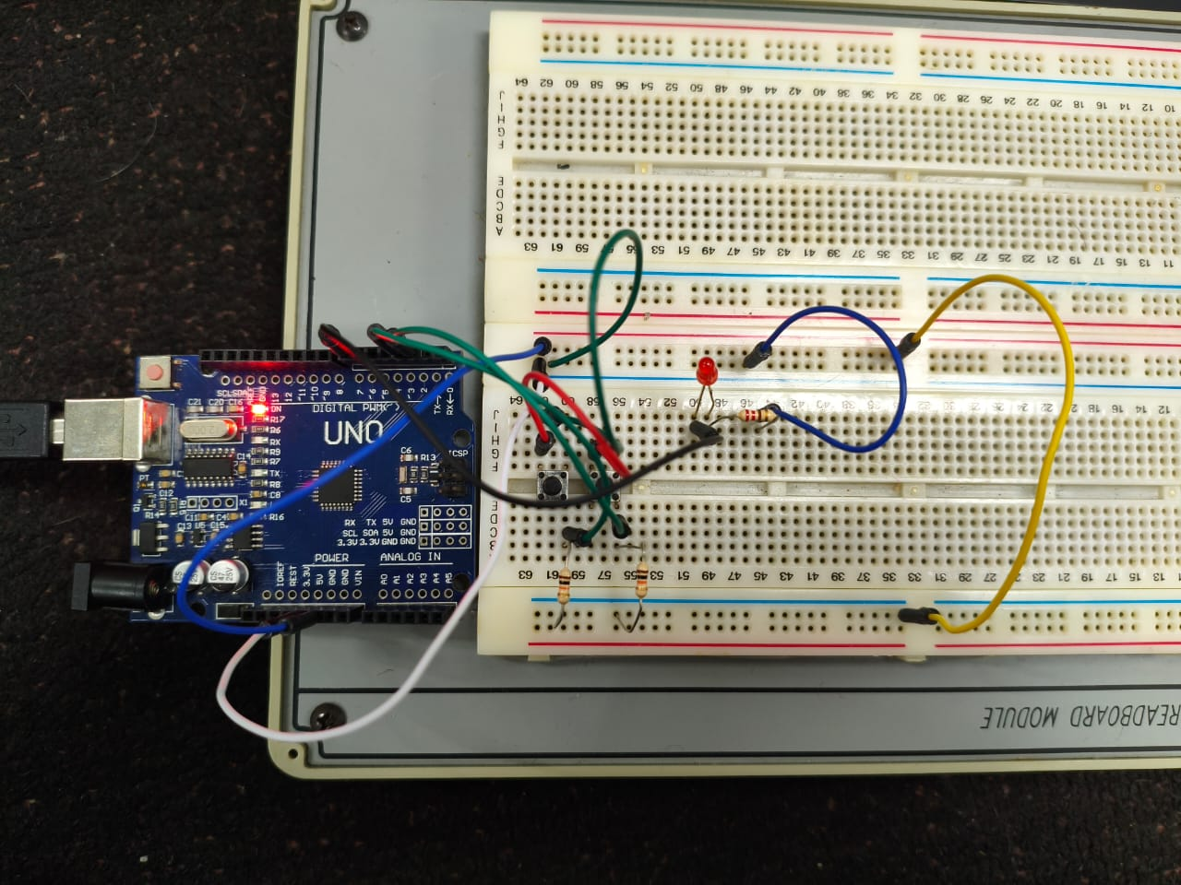

Acknowledgments

Appreciation is expressed to the course instructional team and the technical staff of the Mechatronics Engineering Department for providing the laboratory manuals, physical hardware components, and software tooling documentation required to complete this module. Acknowledgments are also extended to the OpenPLC community and project contributors for maintaining an accessible, open-source IEC 61131-3 development ecosystem.

Student’s Declaration
Certificate of Originality and Authenticity
This is to certify that we are responsible for the work submitted in this report, that the original work is our own except as specified in the references and acknowledgement, and that the original work contained herein have not been untaken or done by unspecified sources or persons.
We hereby certify that this report has not been done by only one individual and all of us have contributed to the report.
We also hereby certify that we have read and understand the content of the total report and no further improvement on the reports is needed from any of the individual's contributors to the report.

We therefore, agreed unanimously that this report shall be submitted for marking and this final printed report has been verified by us.

Signature: Read [ / ]
Name: Muhammad Aqeel Raziq Bin Mohamad Azhan Understand [ / ]
Matric Number: 2314077 Agree [ / ]

Signature: Read [ / ]
Name: Muhammmad Aiman Bin Mohd Khairunnizam Understand [ / ]

Matric Number: 2226273 Agree [ / ]
Signature: Read [ / ]
Name: Muhammad Aqil Syamil bin Abdul Rahim Understand [ / ]
Matric Number: 2416245 Agree [ / ]

